Asp.Net MVC

1. MVC
2. MVC request Life cycle
3. Different return types of a controller action method
4. Difference between Temp data, View, and View Bag
5. HTML helpers in MVC
6. jQuery

# MVC

Model–view–controller (MVC) is a software architectural pattern for implementing user interfaces. It divides a given software application into three interconnected parts, so as to separate internal representation of information from the way that information is presented to or accepted from the user.

MVC is a framework for building web applications using an MVC (Model View Controller) design:

* The Model represents the application core (for instance a list of database records).
* The View displays the data (the database records).
* The Controller handles the input (to the database records).

The MVC model also provides full control over HTML, CSS, and JavaScript.

# MVC request Life cycle

Any web application has two main execution steps, first understanding the request and depending on the type of the request sending out an appropriate response. MVC application life cycle is not different it has two main phases, first creating the request object and second sending our response to the browser.

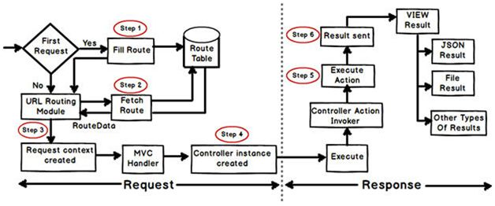

# Different return types of a controller action method

System.Web.Mvc.**ActionResult**

* System.Web.Mvc.**ContentResult**
* System.Web.Mvc.**EmptyResult**
* System.Web.Mvc.**FileResult**
* System.Web.Mvc.**HttpStatusCodeResult**
* System.Web.Mvc.**JavaScriptResult**
* System.Web.Mvc.**JsonResult**
* System.Web.Mvc.**RedirectResult**
* System.Web.Mvc.**RedirectToRouteResult**
* System.Web.Mvc.**ViewResultBase**

# Difference between Temp data, View, and View Bag

**ViewData**

1. ViewData is used to pass data from controller to view.
2. It is derived from *ViewDataDictionary* class.
3. It is available for the current request only.
4. Requires typecasting for complex data types and checks for null values to avoid an error.
5. If redirection occurs, then its value becomes null.

**ViewBag**

1. ViewBag is also used to pass data from the controller to the respective view.
2. ViewBag is a dynamic property that takes advantage of the new dynamic features in C# 4.0
3. It is also available for the current request only.
4. If redirection occurs, then its value becomes null.
5. It doesn’t require typecasting for the complex data type.

**TempData**

1. TempData is derived from *TempDataDictionary* class
2. TempData is used to pass data from the current request to the next request
3. It keeps the information for the time of an HTTP Request. This means only from one page to another. It helps to maintain the data when we move from one controller to another controller or from one action to another action
4. It requires typecasting for complex data types and checks for null values to avoid an error. Generally, it is used to store only one time messages like the error messages and validation messages

# HTML helpers in MVC

**HTML Links**

<%=Html.ActionLink("About this Website", "About")%>

**HTML Form Elements**

There following HTML helpers can be used to render (modify and output) HTML form elements:

* BeginForm()
* EndForm()
* TextArea()
* TextBox()
* CheckBox()
* RadioButton()
* ListBox()
* DropDownList()
* Hidden()
* Password()

# jQuery Methods

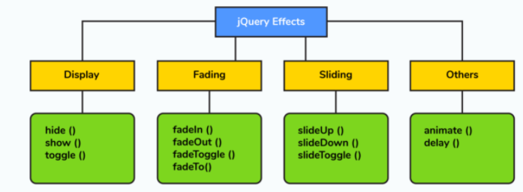

# What is $() in jQuery library

The $() function is an alias of jQuery() function. It is used to wrap any object into jQuery object which later facilitates you to call the various method defined jQuery object. You can pass a selector string to $() function, and it returns a jQuery object which contains an array of all matched DOM elements.

#### Syntax:

$(document).ready(function() {

$("p").css("background-color", "pink");

});

# Selectors in jQuery

If you want to work with an element on the web page, first you need to find it. Selectors find the HTML elements in jQuery. There are many types of selectors. Some basic selectors are:

* **Name:** It is used to select all elements which match with the given element Name.
* **#ID:** It is used to select a single element which matches with the given ID
* **.Class:** It is used to select all elements which match with the given Class.
* **Universal (*):** It is used to select all elements available in a DOM.
* **Multiple Elements E, F, G:** It is used to selects the combined results of all the specified selectors E, F or G.
* **Attribute Selector:** It is used to select elements based on its attribute value.